
Mathematics at Falconhurst School
Impact
As children progress through Falconhurst Primary School pupils will leave us prepared for the next stage in their lives with:

Quick recall of facts and procedures
The flexibility and fluidity to move between different contexts and representations of mathematics
The ability to recognise relationships and make connections in mathematics
Confidence and belief that they can achieve
The knowledge that maths underpins most of our daily lives
Skills and concepts that have been mastered.

A mathematical concept or skill has been mastered when a child can show it in multiple ways, using the mathematical language to explain their ideas, and can independently apply the concept to new problems in unfamiliar situations and this is the goal for our children.

These will be assessed through: assessment, tracking, pupil progress meetings, performance management, moderation and standardisation.
Summative/reported – HEADSTART and SATs
Standardisation (YR – Y6)
Summative/ diagnostic (where necessary) – White Rose, NCETM
Formative / ongoing

Intent for our mathematicians
As a foundation for our Mathematics curriculum, we use White Rose Maths, which offers a framework to teach the Mathematics Programme of Study as laid out by the National Curriculum and the Statutory Framework for the Early Years Foundation Stage, alongside other high-quality resources, including National Centre of Excellence in the Teaching of Mathematics (NCETM). White Rose has been influenced, inspired and informed by the work of leading maths researchers and practitioners across the world and is based on the latest pedagogical research.

At Falconhurst, we strive to have children develop a positive attitude and interest towards mathematics. From the earliest years, we encourage children to ‘have a go,’ to have children notice numbers, patterns, shapes, and connections and to be able to discuss their findings with others. It is important to instil a love of learning from an early age and to teach children that we learn from making mistakes.

We aim for all pupils to…

Fulfil the requirements of the Early Years Framework and the National Curriculum
Build their confidence and resilience to ensure that they are fluent in the fundamentals of Maths so that they develop a deep knowledge of mathematical facts and procedures that are essential to their future success.
Be able to solve problems by applying their Maths to a variety of problems with increasing sophistication, including in unfamiliar contexts and to model real life scenarios.
Reason mathematically by following a line of enquiry and develop and present a justification, argument or proof using mathematical language
Have opportunities to use and apply their Maths across the curriculum.

Characteristics of an mathematicain
- The ability to have an understanding of the important concepts and an ability to make connections with mathematics  - A broad range of skills in using and and applying mathematics  - Fluent knowledge and recall of number facts and the number system  - The abiltiy to show initiative in solveing problems in a wide range of concepts, including the new or unusual.  - The ability to think independently and to persevere when faced with challenges, showing a confidence of success |  | - The ability to embrace the value of learning from mistakes  - The ability to reason, generalise and make sense of solutions  - Fluency in performing written and mental calculations and mathematical techniques  - A wide range of mathematical vocabulary  - A commitment to and passion for the subject.
Implementation of mathematics
The vertical accumulation of disciplinary and substantive knowledge and skills typically expected from Years 1 to 6 is mapped below
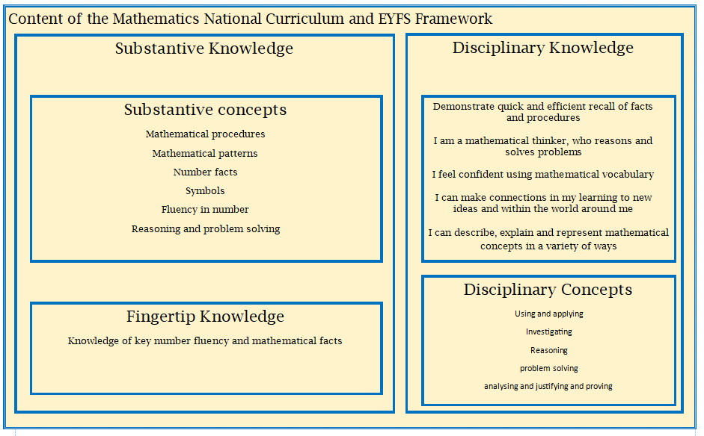
Essential Early Years Opportunities | Essential National Curriculum Opportunities  Key Stage 2
Have a deep understanding of number to 10, including the composition of  each number;  Subitise (recognise quantities without counting) up to 5;  Automatically recall (without reference to rhymes, counting or other aids)  number bonds up to 5 (including subtraction facts) and some number bonds to 10, including double facts  Verbally count beyond 20, recognising the pattern of the counting system;  Compare quantities up to 10 in different contexts, recognising when one  quantity is greater than, less than or the same as the other quantity;  Explore and represent patterns within numbers up to 10, including evens and odds, double facts and how quantities can be distributed equally | Count and calculate in increasingly complex contexts. Including those that cannot be experienced first hand  Rigorously apply mathematical knowledge across the curriculum, in particular in science, technology and computing  Deepen conceptual understanding of mathematics by frequent repetition and extension of key concepts in a range of purposeful contexts  Explore numbers and place value so as to read and understand the value of all numbers  Add and subtract using efficient mental and formal written method  Multiply and divide using efficient mental and formal written methods  Use the properties of shapes and angles in increasingly complex and practical contexts, including in construction and engineering contexts  Describe position, direction and movement in increasingly complex contexts  Gather, organise and interrogate data  Understand the practical value of using algebra
Essential National Curriculum Opportunities
Key Stage 1

Count and calculate in a range of practical contexts
Use and apply mathematics in a everyday activities and across the curriculum
Repeat key concepts in many different practical ways to secure retention
Explore numbers and place value up to at least 100
Add and subtract using mental and formal written methods in practical contexts
Multiply and divide using mental and formal written methods in practical contexts
Explore the properties of shape
Use language to describe position, direction and movement
Use and apply in practical contexts a range of measures, including time
Handle data in practical contexts
Please find The White Rose Ready to Progress Statements Policy and and The Calculation Policy that we follow at Falconhurst School.

Calculation Policy
Ready to progress Mathematics

